(EDA background knowledge)

* EDA signals are composed by the superposition of two different components.
  + Skin conductance response (SCR)
    - be observed when the sudomotor nerve is activated
    - widely used to measure the sympathetic nervous system
    - From a morphological point of view, SCR is represented by a peak or a burst of peaks with different amplitudes, slopes, and decays depending on the nature of the stimulus.
    - The energy of the SCR component ranges from 0.05 to 1.5 Hz.
  + Skin conductance level (SCL)
    - represents the baseline of the skin conductance
    - varies among people, depending on their physiological states and autonomic regulation
    - Given the slow response of the SCL component, the useful information ranges from 0 to 0.05 Hz.

<EDA features>

1. Electrodermal activity sensor for classification of calm/distress condition [1]
   1. Temporal: mean (MSC), standard deviation (SDSC), maximum (MASC), minimum (MISC), dynamic range (DRSC, MASC - MISC), mean of the first derivative (FMSC), the standard deviation of the first derivative (FDSC),

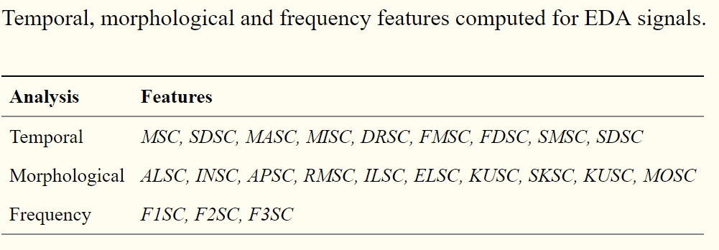

[1]: @article{zangroniz2017electrodermal,  
 title={Electrodermal activity sensor for classification of calm/distress condition},  
 author={Zangr{\'o}niz, Roberto and Mart{\'\i}nez-Rodrigo, Arturo and Pastor, Jos{\'e} and L{\'o}pez, Mar{\'\i}a and Fern{\'a}ndez-Caballero, Antonio},  
 journal={Sensors},  
 volume={17},  
 number={10},  
 pages={2324},  
 year={2017},  
 publisher={Multidisciplinary Digital Publishing Institute}  
}

[2]: